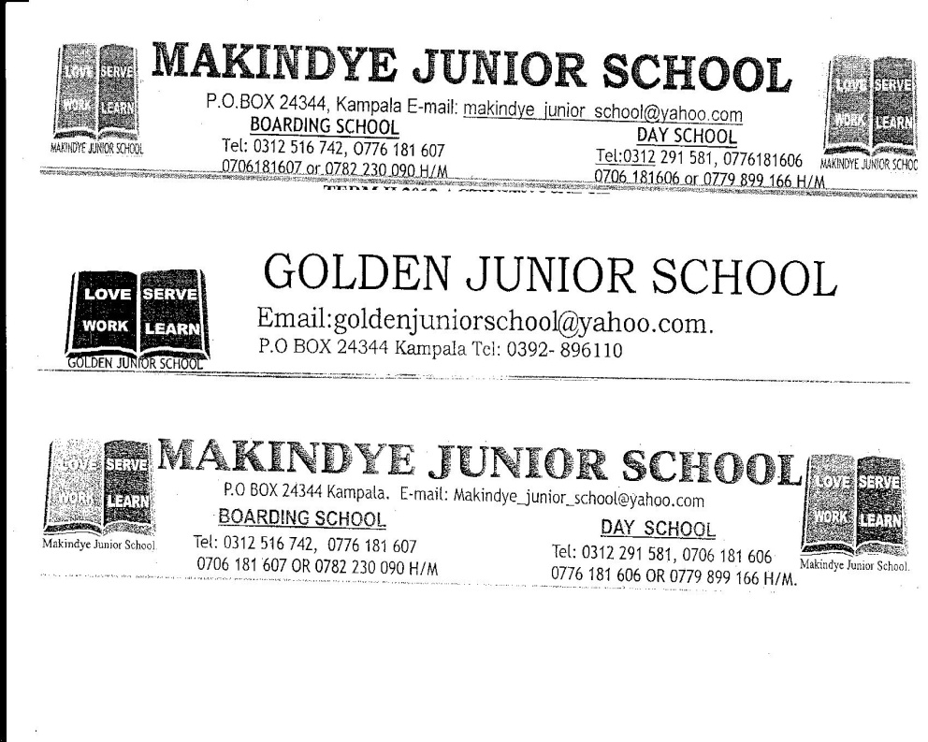
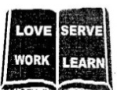
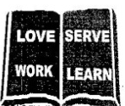
THE REAL SCHOOLS
LEARNER’S EMPOWERMENT ACTIVITY
P.4 TERM I 2026
TOPIC: DESCRIBNG PEOPLE AND OBJECTS

Makindye Junior School

Golden Junior
School

Victoria P/S

An excellent first grade and excellent character for every pupil

NAME………………………………………………… ………………………CLASS: ………………………….
SCHOOL……………………………………………………………………………………………………………..
SESSION 3
Topic: Describing people and objects
Sub -topic: Describing people

What I will understand (learning outcome)
I __________ will be able to understand regular verbs.

How I will use this knowledge in my daily life.
This knowledge will help me to effectively communicate using regular verbs in different tenses.

LESSON NUMBER 07
High proficiency level questions
Write 20 doing words that you know.
_______ _______ _______ ___________ ___________ ________ _________ __________ __________ ________ __________ _________ _________ _________ ____________ ___________ ___________ ___________ __________ __________ __________ _________ _____________ __________

Competences
I will be able to;
- transform regular verbs that add d, in simple past tense and past participle.
- transform regular verbs that add ed in simple past and past participle
- transform regular verbs that double the last consonant before adding ed.
- transform regular verbs that add “ied”in simple past and past participle.
- transform irregular verbs that change the same way in simple past and past participle.
- trans form irregular verbs that do not change in simple past and past participle.
- transform regular verbs that change completely.
- Understand a
Learning outcome
In this session, you will be able to understand how to use verbs in different tenses in daily life.

Relevance
You will be able to effectively communicate to people around you.

Life skills and values
- Effective communication
- Critical thinking
- Critical observation

Values
Care
Concern
Love
Honesty

Back ground knowledge.
You have got some knowledge about activities done on daily basic activities ie sleeping, eating writing bathing etc

Learning aids
Dictionary
Text books

Content
Verbs that add “d” in simple past and past participle tense
Write down 5 action words that you know.
Key learning principle
- A verb is a word in action.
OR A Verb is a word that tells you what to do.
- Regular verbs are verbs that follow a specific rule when changing to simple past and participle form.
- Regular verbs that add “d’ end in a vowel love letter “e”
Examples

Verbs | Simple past | Past participle
dance | danced | danced
love | loved | loved
change | changed | changed
compete | completed | completed
arrange | arranged | ____________________
examine | examined | _____________________
move | moved | ____________________
use | used | ____________________
live | lived | _____________________
hope | hoped | ____________________
advise | ________________ | _____________________
Sentence practice
- Peter danced at my birthday party last year.
- Musa loved circular cakes last year.

Hands on activity
Construct meaningful sentences using the given verbs in different tenses.
- Changed _________________________________________
- Completed ___________________________________
- Arranged _______________________________________

Competence two
Regular verbs that add” ed” in simple past tense and past participle.
Write down any 5 verb that end in a consonant letter.
1___________________
2___________________
3___________________
4.___________________
5___________________
Most verbs that add “ed” in simple.
- Past and participle end in consonant letter ie n, k, p, t etc
Verb | Simple past | Past participle
Open | opened | opened
cook | cooked | cooked
work | worked | worked
jump | __________________ | _________________
pick | ___________________ | __________________
pack | ___________________ | ___________________
allow | allowed | allowed
play | played | played
paint | painted | painted
_______________ | planted | planted
fill | _______________ | _____________

Sentence practice
- My brother opened the door by himself.
- Mother cooked delicious meal last evening.

Hand on activity.
- Construct meaningful sentences using the given verbs in different tenses.
- jumped______________________________________________
- packed______________________________________________
- allowed_____________________________________________

Mini activity
1. Arrange in alphabetical order
a) open, cook, walk, paint
________________________________________________________________
b) dance, love, use, live
________________________________________________________________
2. Complete the table below correctly.
Verb | Simple past | Past participle
care | cared | ________________
_____________ | loved | ________________
prune | ______________ | pruned
pick | _________________ | _____________________
_________________ | allowed | _____________________
move | ___________________ | moved
hope | ____________________ | hoped
______________ | used | _______________
________________ | lived | ________________

3 Construct meaningful sentence using these word
i) power ____________________ ii) pour _________________________
Competence 3
Regular verbs that double the consonant letter before adding “ed”
- List down any three examples of verbs in that have consonant form
1___________________
2____________________
3_____________________
Key learning principle
Some verbs that double the last letter are have cvc rule ie
C-consonant
V- vowel
C- consonant.
They usually double the last letter before adding “ed” in the past and past participle.
Examples of regular verbs that double the letter before adding “ed”

Verbs | Simple past | Past participle
admit | admitted | admitted
stop | stopped | stopped
fit | fitted | fitted
mop | mopped | mopped
clap | clapped | clapped
map | _______________ | ________________
prefer | _________________ | ________________
prefer | ___________________ | _________________
step | __________________ | _______________
plan | _________________ | __________________

Hands on activity
Complete the table below correctly
Verb | Past simple | Past participle
map | mapped | _____________
______________ | mopped | _____________
_______________ | ___________ | clapped
fit | ___________ | ________________

Competence four
Regular verbs that drop “y” to “ied” in past simple and past participle tick verbs that drop “y”to” ied”

Play, hurry, pray, study, copy, fly, cry, marry, bury

Key learning principle
Regular verbs that drop y to “ied” and in a consonant letter” y” and proceeded by consonant letter.
Example
Carry-carried
Examples of verbs that add “ied”
Verb | Simple past | Past participle
cry | cried | cried
marry | married | married
carry | carried | carried
study | studied | studied
hurry | hurried | hurried
copy | ______________ | ________________
purify | _______________ | _________________
testify | _________________ | _________________

Hands on activity
Complete the below correctly
Verb | Simple past | Past participle
___________ | cried | ________________
testify | ____________ | testified
purify | _____________ | Purified
____________ | ____________ | married
study | ____________ | _________________
_____________ | carried | ___________________

Sentence practice
- The little baby over cried last night.
- My brother studied in that school last year.

Hands on activity
Construct meaningful sentences using the given verbs in different form.
- married________________________________________________
- purified________________________________________________
- testified______________________________________________

Mini activity
1. Arrange in alphabetical order
a) cry, marry, hurry, purify
_______________________________________________________________
b) mop, step, map, fit
______________________________________________________________
2. Use words in the brackets to correctly to complete the sentences below
a) My father __________________ maize yesterday. (plant)
b) My uncle got ______________ to a Muganda lady. (marry)
c) The boy _______________ for its mother for over an hour. ( cry)

Use a dictionary or any other device to look up the following words and use in a sentence
a) magnify _______________________________
b) admit_________________________________
Competence 5
A table showing height and weight of people.
Key Learning principle
Height _____ The measurement of how tall a person or something is
- It can be measured m centime or meter.
- Weight ____ shows how heavy. Something/ somebody is
- It can be measured m kilogram or pounds
The table below shows the height and weight of learners in p.4 joy study it carefully and then answers question that follow
Name | Height | weight
Opio | 15m | 25kg
Namata | 20m | 40kg
Okello | 30mg | 52kg
Aine | 45m | 60kg
Magoba | 15m | 25kg
Ojak | 22m | 35kg
Naganda | 25m | 45kg

Question let us answer some of the questions together
1 How many learners are shown in the table above
Seven learners are shown in the table above
2. Which learners weighs the same kilogram
Opio and Magoba weigh the same kilogram.
3. Write the following in full.
i) m meter ii) kg kilogram(s) kilogrammes( s)
Hands on activity
4. How many kilograms does opio
Opio weighs twenty- five kilogram

Hands on activity
5. What is the difference between Aine and Okello’s height.
_________________________________________________________________
6. Write Namata’s height in words.
_________________________________________________________________
7. For which class is the above table?
________________________________________________________________
8. Which learner weighs the highest kilogram?
________________________________________________________________
Mega activity
Fill in the blank space with the most suitable word
1. Mr Opio is taller __________________ Mr Okello
2. Th twins shared the apples _____________ themselves.
3. The _______________ does not have any bread for sale today.
4. ________________ Betty and Beth are tall.
5. The baby is fond _____________ taking juice early in the morning.
Use these words in a sentences to show that you know the difference in their meaning
6. berry __________________________________________________________
7. bury ___________________________________________________________
Use the correct form of the word given in brackets to complete the sentences
a) The teacher _______________ all our books of English. (mark)
b) Of the twins, Kato is the ________________. ( tall)
c) Our king is ______________ than the prince (brave)
d) The nurses _______________ the patient yesterday. (treat)

The table below shows the result of measurement of heights and weights done in p.4 faith in term iii 2025 study it carefully and answer the questions that follow in full sentences

Name | Height ( cm) | Weight (kg)
John | 175 | 70
Emilly | 160 | 55
Micheal | 180 | 80
Sarah | 165 | 60
David | 180 | 75
Olivia | 155 | 750
William | 145 | 50
James | 178 | 72
Questions
1. Which class is shown in the above table?
_______________________________________________________________
2. How many learners are shown in the table above.
______________________________________________________________
3. Which learners weigh the same kilogram according to the table.
_______________________________________________________________
4. Who weighs the least kilogramme?
________________________________________________________________
5. Who is the tallest learner according to the table?
_______________________________________________________________
6. When was the measurement in table above taken?
________________________________________________________________
7. Write cm in full
________________________________________________________________
8. Which learner weighs the highest kilogramme?
_______________________________________________________________

LESSON 08
High proficiency level question.
Write ten doing words or a word in action that you know.
_________ _________________ __________________ ___________ ________________ __________ _____________ ___________ ___________ ___________ ___________ _______________ ______________ ______________ ____________ _________ ______________ ________________ __________
Competences
I will be able to;
- Understand irregular verbs that change the same way in simple past and past participle.

- Understand irregular verbs that do not change in simple past and past participle.

- Understand irregular verbs which change completely in simple past and past participle.

- Understand a jumbled story.

Competence one

Transforming irregular verbs that change the same way in simple past and past participle.
Key Learning principle
A verb is word in action irregular verbs are verbs that have no uniform way of changing
Write down any 5 verbs that change completely in past tense.
1.__________________________
2__________________________
3__________________________
4__________________________
5__________________________
Examples of verbs that change the same way in simple past form and past participle form
Present | Present participle | Past( with has or have)
buy | bought | bought
bring | brought | brought
lay | laid | laid
lead | lent | lent
lose | lost | lost
light | light | light
pay | paid | paid
learn | learnt | learnt
sell | sold | sold
send | sent | sent
shoot | shot | shot
complete the rest of the table

sleep | slept | slept
stand | ____________ | stood
tell | told | ____________
think | _____________ | thought
__________ | wept | wept
win | ____________ | won
teach | taught | _________________
_____________ | taught | _________________
_____________ | fought | fought
find | ________________ | found
burn | burnt | ________________
bend | _____________ | bent
catch | caught | _______________
feed | ________________ | fed
___________ | got | got
hear | ________________ | heard
meet | met | _______________

Hands on activity
Complete the table below correctly

Verb | Past | Past participle
keep | ______________ | kept
bleed | bled | _________
_____________ | bent | ___________
meet | _______________ | met
Sentence practice
- My father bought a rectangular table yesterday.
- Our teacher of English taught us last week.

Hands on activity
I can also now construct meaningful sentences using the given verbs in different tenses.
- caught____________________________________________________
- fought__________________________________________________
- sold__________________________________________________

Arrange in alphabetical order.

a) head, burn, burry, bleed
_________________________________________________________________
b) fight, get, burn, burry, bleed
_________________________________________________________________
c) fight, get weep, stand
_______________________________________________________________

Competence 2
Transforming irregular verbs that do not change in simple past and past participle form.
Irregular verbs do not have uniform of changing.
Sort out verbs that do change the same way in the simple past and past participle form

cast, tell, cast, teach, burst, meet, hurt, cut, dig, put, feed, broad cast

- ______________________________ 2_________________________________
3________________________________4__________________________________
5________________________________6_________________________________

Examples of verbs that do not change

Verbs | present participle | Past participle
cost | cost | cost
burst | bust | burst
put | ______________ | put
______________ | ________________
_____________ | cast | _____________
hurt | hurt | ______________
broadcast | ________________ | broadcast
shut | _________________ | shut

Hands on activity
Complete the table below

Verb | Present participle | Past participle
shut | ___________ | _______________
____________ | burst | _______________
broad cast | _______________ | _____________
____________ | ___________ | _______________
Sentence practice.
- The old man cut the tall tree last evening.
- Mother put a lot of salt in sauce yesterday.

Hands on activity
I can also construct meaningful sentences using the given verbs in different tenses.
- broadcast_____________________________________
- hurt__________________________________________
- shut_________________________________________

1. Arrange in alphabetical order
a) put, cut, shut, hurt
______________________________________________________________
b) cast, cost, burst, broadcast
______________________________________________________________
Use the correct form of the words given in the brackets to complete these sentences
a) The news about the mad woman was _________________ yesterday (broadcast)
b) My father ________________ his money from that round about. (lose)
Tom has _______________ himself on a knife. (cut)

Competence Three
Examples of verbs that change completely in the simple past and past participle form.
Verb | Present participle | Past participle
eat | ate | eaten
run | ran | run
drink | drank | drunk
use a dictionary to look up these words and complete
see | _______________ | seen
shake | shook | _____________
speak | ______________ | spoken
______________ | ________________ | swum
_______________ | took | taken
throw | ____________ | thrown
weave | wove | _____________
____________ | withdraw | withdrawn
drive | ________________ | driven
choose | choose | _______________
break | _____________ | broken
________ | flew | flown
forgive | ____________ | forgiven
give | gave | __________________
grown | ______________ | grown
_____________ | hid | hidden
mistake | __________________ | mistaken
ride | rode | ________________
know | __________________ | known
_________________ | rang | rung

Hands on activity
Complete the table blow correctly

Verb | Present participle | Past participle
hide | ______________ | hidden
ride | rode | _______________
____________ | rode | _________________
grow | ____________ | _________________
______________ | _____________ | given
eat | ____________ | __________________

Arrange in alphabetical order
a) hide, fly, grown, ring
________________________________________________________________
b) write, withdraw, weave, walk
________________________________________________________________

Competence four
A jumbled story
This is a composition to test the learner whether they can tell a story in its correct order.

Note: While reading jumbled story, you need to read twice or thrice depending on the complexity. Then put numbers the margin of the order, according to the findings then read. Through your new version and see whether it the correct order.

Examples
a) She treated my uncle and he got well.
b) Last weekend, my uncle got an accident.
c) The passer- by saw him and carried him to the nearby clinic.
d) He was going to the market to buy furniture from his trusted carpenter.
e) The clinic had a kind very nurse who admitted my uncle

A Good story
a) Last weekend my uncle got an accident.
b) He was going to the market to buy furniture from his trusted carpenter.
c) The passer-by saw him and carried him to the nearby clinic.
d) The clinic had a very nurse who admitted and treated him.
e) She treated my uncle and he got well.

Hands on activity
Rearrange these sentences to form a good story
a) James is followed by Thomas
b) Thomas is our first born.
c) I am the last born
d) We are five children our home
e) Then the twins follow James.
a) _______________________________________________________________
b) ______________________________________________________________
c) _______________________________________________________________
d) _______________________________________________________________
e) ____________________________________________________________

a) The police came with dogs.
b) He was taken to the police station.
c) Father called the police for rescue.
d) A thief broke into our house last night.
e) The dogs found the thief hiding the bush.
a) ______________________________________________________________
b) ______________________________________________________________
c) ______________________________________________________________
d) ______________________________________________________________
e) _____________________________________________________________
Mega activity
Fill in the blank space with a suitable word
1. How __________________ is a packet of salt?
2. Tom is ________________ honest man.
3. Agatha prefers dancing ________________ swimming.
4. I felt very sad ____________ our house caught fire.
5. John, the __________________ , mends broken shoes.
For questions 6-15 use the correct form of the word given in the
brackets to complete the sentences
a) There are ____________ books. (he)
b) Jonah was the _____________ in the race. (four)
c) The bad girls are ______________ to the teachers. (lie)
e) The goat _____________ the neighbor’s maize yesterday. (destroy)
Arrange the words in alphabetical order.
a) tear, teach, abuse, tease
_______________________________________________________________
b) accuse, attract, abuse, effect
_____________________________________________________________
Write the following in full
a) kg ___________________
b) can’t _________________
c) Hon _________________
Rearrange these words to form correct sentences
a) Your friend is what name?
_____________________________________________________________
b) Our enjoys singing teacher.
____________________________________________________________
c) beautiful what girl Sheila a is!
___________________________________________________________

LESSON 09
Competence one
Undersetting all common abbreviations
Write down any 5 abbreviations you know
1) _________________ 2) ___________________ 3) ___________________
4) ________________ 5) _____________________

Key Learning principle
Abbreviations are short forms of words.

Examples
P T O _ please turn over Sec _ secretary/second
C/O _ care of kg _ kilogram(s)/ kilogramme(s)
a.m._ before noon cm _ Centimetre/centimeter(s)
p.m._ after noon hr. _hour
Hon _ honorable Sh. _ shillings
Dr _ Doctor Mon _ Monday
R.S V. P _ please reply Dec _ December+-
Fr _Father Vol _ Volume
R I P _ rest in peace Prof _Professor
Wed. _ Wednesday Tue. _Tuesday
PO -- the Post office tel _ telephone number
Rd _ Road

Hands on activity
Write the following in short form
a) July ___________ d) Doctor ___________
b) hour __________ e) October _____________
c) Professor _______

Competence 2
A contraction is a short form of a helping verb together with a pronoun.
Examples
a) I’m _ I am they’re _they are
you’re _ you are It’s _ It is
aren’t _ are not we’re _ we are
isn’t _ is not he’s _ he is
wasn’t _ was not she’s _ she is
weren’t _ were not weren’t _ were not
doesn’t _ does not don’t do not

Hands on activity
Write in full
I’m ________________ he’s _______________ weren’t ________________
Aren’t _______________ don’t ______________ doesn’t ________________

Mini activity
Write the following in full
1. Isn’t __________ 7. P T O ____________
2. aren’t __________ 8. c/o ______________
3. Dr _____________ 9. Hon._____________
4. p.m. ____________ 10. a.m._______________
5 Lab_______________ 11. Dec _______________
6 don’t _____________ 12. wasn’t _____________

Competence Three
A notice
A notice is a sheet of paper giving written or printed information, usually put in a public place.

Read the notice below which appeared on the school notice board in the 10th week of term one 2024
Makindye Junior School has organized the Annual Thanks giving Service will will take place on Saturday, 6th May,2024 Starting at 9:00a.m 12:00p.m close to the pre primary building. Come and listen. Tea will be served in the tents near the laboratory.
All the parents of Makindye Junior School are invited
Head teacher
20th April,202
Questions
1. When did the notice appear on the board,
The notice appeared on the board in the 10th week of term one 2024.

2. How long will the service take?
The service will take two and a half hours.

3. Where will the service be?
The service will be in close to the preprimary building.

4. When will the service take place.
The service take place on 6th may, 2024.

5. At what time will the service start.
The service will start at 9:00a.m.

Hand on activity
1. When will the service end?
______________________________________________________________
2. Who is invited according to the notice.
______________________________________________________________
3. Which choir is presenting.
______________________________________________________________
4. At what time of day will the service end?
______________________________________________________________
5. Where will tea be served?
________________________________________________________________
6. Who wrote the notice?
________________________________________________________________
7. When was the notice written?
________________________________________________________________
Mega activity
Fill in the blank space with the a suitable word
1. Mariam has gone to _____________ airport.
2. That is the lady _______________ won the beauty contest.
3. _______________ Betty and Grace are tall.
4. Martin is shorter ______________ Jolly.
5. Is there _________ food at home?

Use the words in the brackets to complete the sentences
6. The school choir has______________ a nice song. (singing)
7. She crossed the road _______________ and got an accident. (care)
8. _______________ is the key to success. (educate)
9. I _____________to school late but the teacher meet. (go)
10. She __________ to me. (lie)
11. Bashir speaks English very __________. (good)
12. You always ___________ church service. (attend)

Arrange these words in alphabetical order.
13. come, dance, move, repair
______________________________________________________________
14. Match, watch, switch, push
______________________________________________________________
Construct meaning sentences using these words to show that you know the difference in their meaning
15. knead __________________________________________________________
16.need ____________________________________________________________

Complete the table below correctly

Verb | Present participle | Past participle
come | came | ___________________
______________ | taught | ___________________
forgive | _________________ | ___________________
compare | _________________ | _________________
_______________ | completed | ____________________
_________________ | married | _____________________

Section B
Use the following words to compose a story describing your mother
a) beautiful
b) honest
c) lady
d) fat
e) bright

